Lecture Lecture 5 9/9/2020

1. Quiz
   1. Big-O Notation
      1. This is what really bothered everyone.
      2. 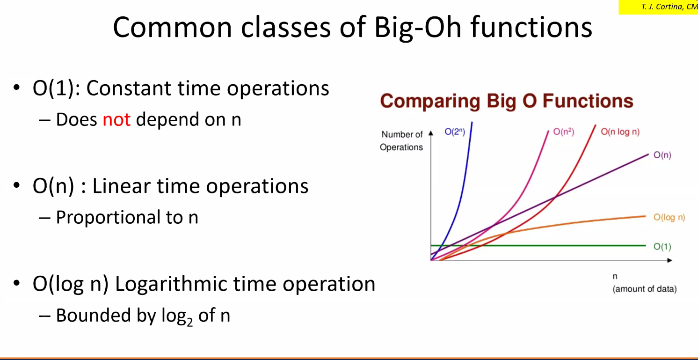
      3. Loops
         1. No loops
            1. O(1)
            2. If you are lucky
         2. One For loop
            1. O(n)
         3. Nested For Loops
            1. O(n^2)
         4. Hint: When you look at loops, see if it’s nested because nested = nxn as opposed to two separate loops which would just be 2n.
         5. While Loops
            1. O(n)
      4. Matrices
         1. O(log2n)
      5. Copy Con
      6. Binary Search
         1. 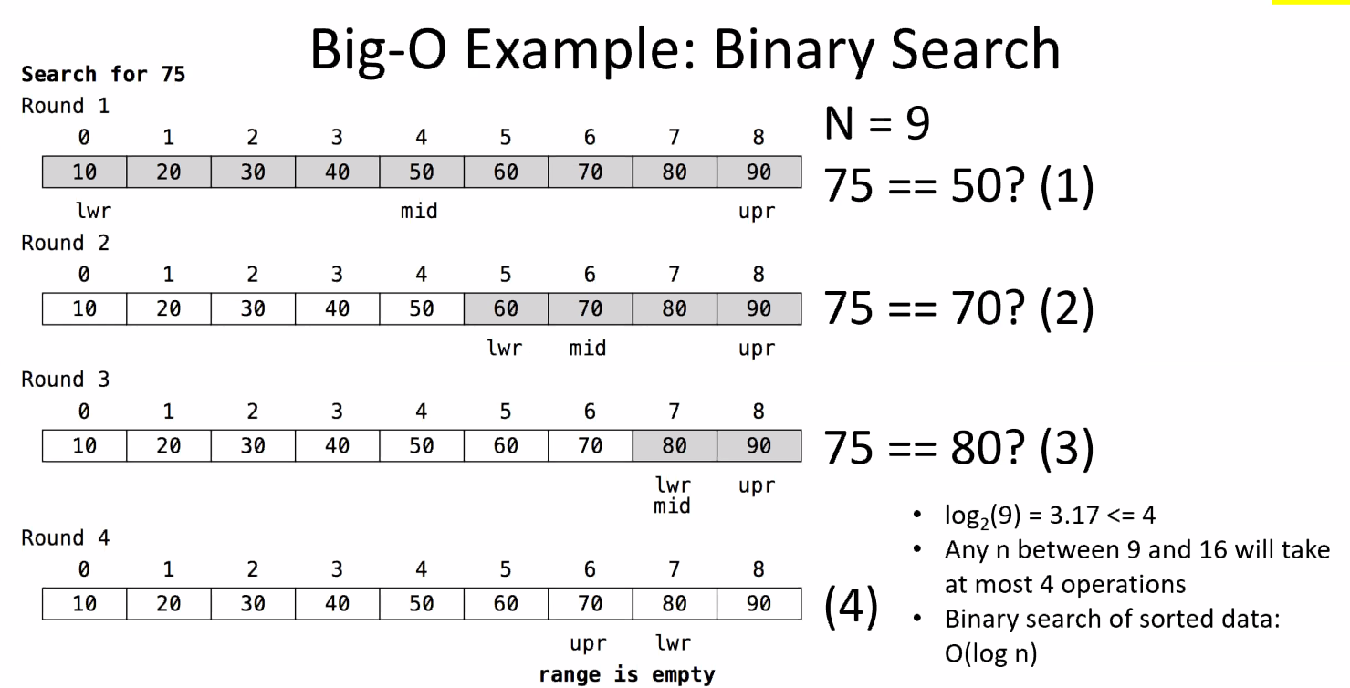
         2. This one is an O(log n)
2. Project K1
   1. We are going grocery shopping.
      1. Container: holds the grocery items
      2. But what sort of container are we using
3. Lectures
   1. Arrays and Vectors
      1. Array Abstract Data Type
         1. Definite:
            1. Capacity/Size – max number of elements that can be stored, cannot change
         2. Fixed Capcity Array
            1. Capacity is constant
            2. Set at container definition at design(compile) time
         3. Two Flavors
            1. Standard Arrays

Smart Wrraper around native array

Std::array from the <array>

Ex. Std::array<Student,10> myArray;

* + - * 1. Native arrays

Or C-style or raw

AVOID

Ex: Student myArray[10];

* + - 1. Vector Abstract Data Type Common Implementation choices
         1. Definitions:

Capacity – max number of elements that can be stored

Size – number of elements that are stored

* + - * 1. Fixed Capacity Vector

Capacity is constant

Set at container construction during runtime or design(compile)

* + - * 1. Extendable Capacity Vector

Capacity is dynamic and changes during runtime

Initialized at container construction during runtime

Grows and shrinks during runtime

* + - 1. How it relates to our project
         1. Vectors can be used to store in different datatypes within it.
         2. Vectors’ size and capacity have different qualities than arrays.
         3. Because of this, they are ideal for being our container for our project.
      2. Vector Implementation
         1. 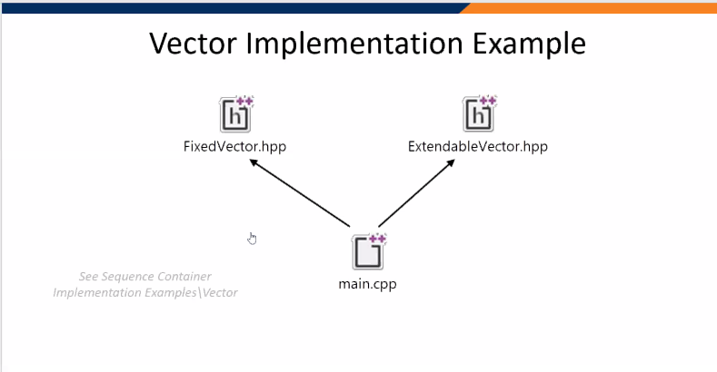
      3. See Sequential Container Code which is now online
         1. It shows template<type T> class
         2. The Constructors, destructor, and assignments are all vectors
         3. Vector related terms

Push_back

Erase

Set

Insert

Begin()

End()